MLP on GARCH- CALL dataset

Accuracy- 95.4545532 MAE- 41.42

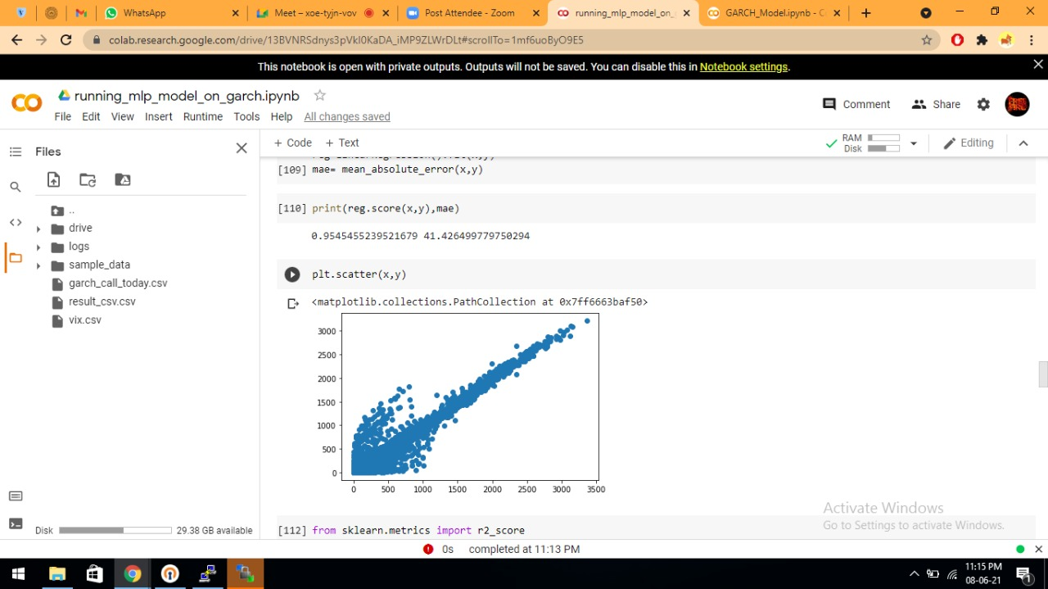

MLP on GARCH- Call (ITM) dataset

Accuracy-94.63799 MAE- 50.948139

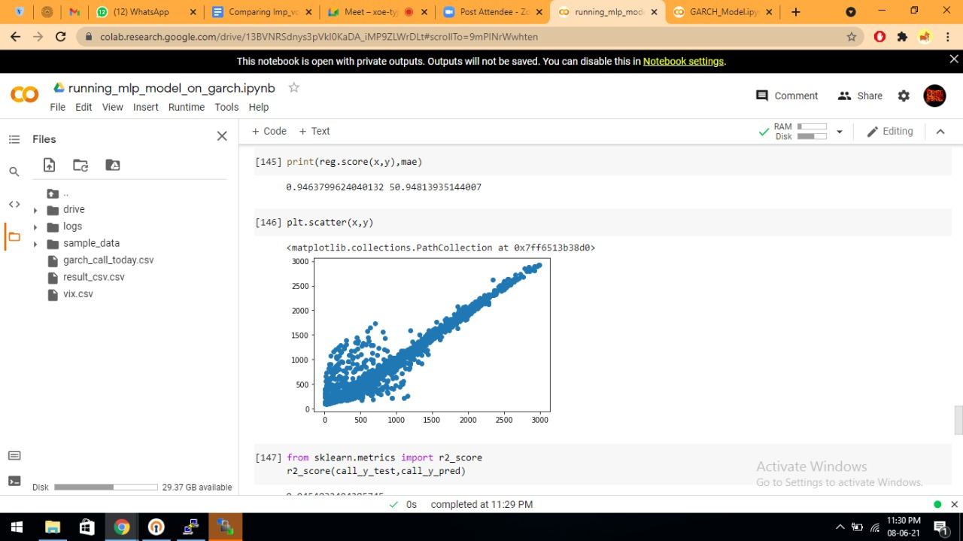

MLP on GARCH- Call (OTM) dataset

Accuracy- 50.13577 MAE- 34.4464

MLP on GARCH- Call(Deep ITM) dataset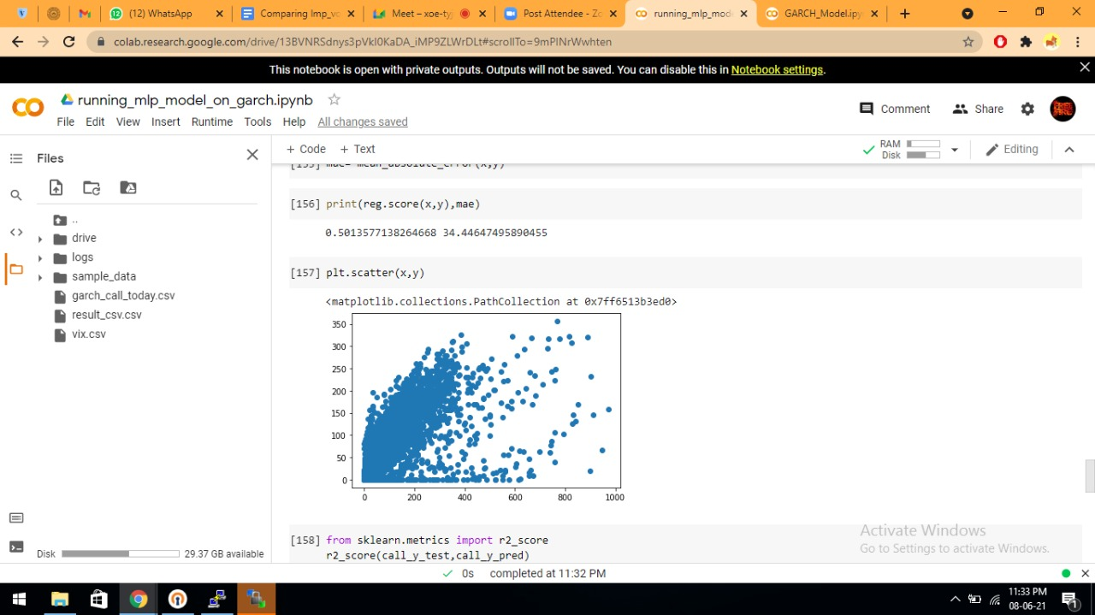

Accuracy- 25.23 MAE- 1794.59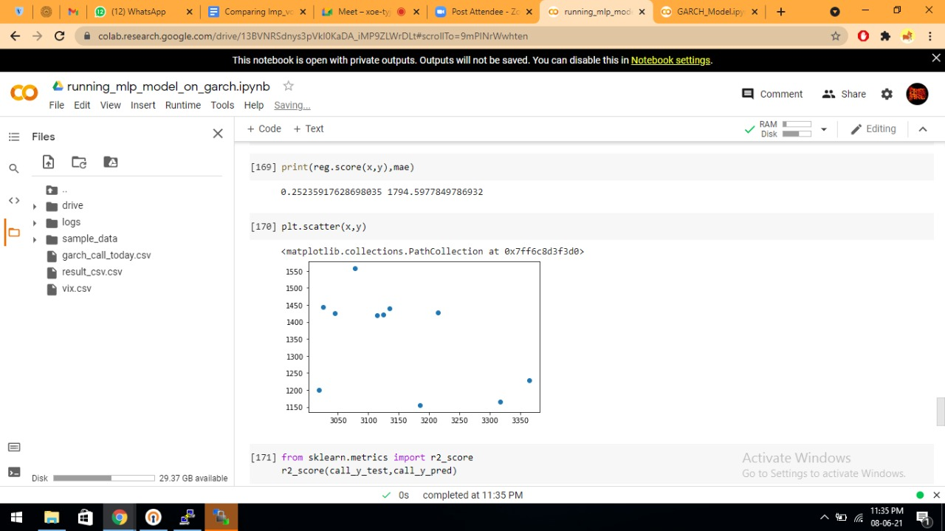

Black-Scholes Model on Garch Dataset

Accuracy- 94.54474 MAE- 43.181500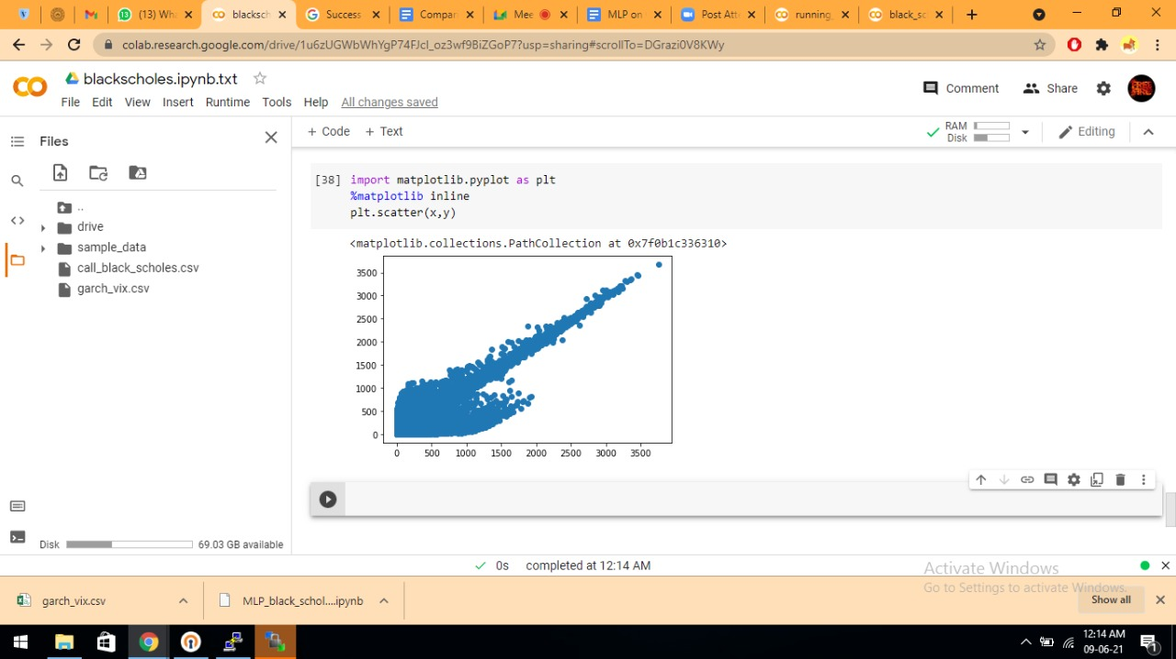

Black Scholes model on ITM dataset(Garch Dataset)

Accuracy-93.35554 MAE- 61.8361

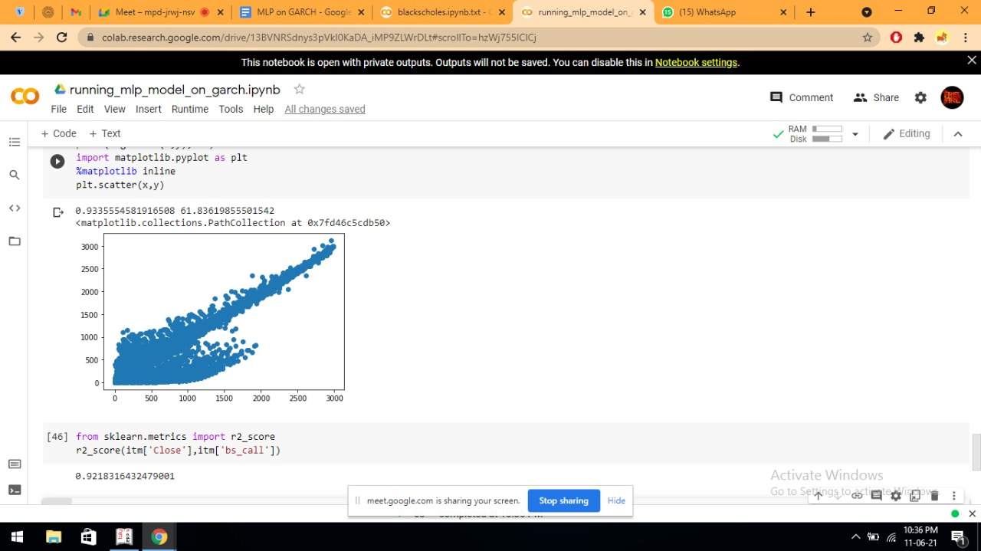

Black Scholes model on Deep-ITM dataset(Garch Dataset)

Accuracy- 89.844 MAE- 35.939

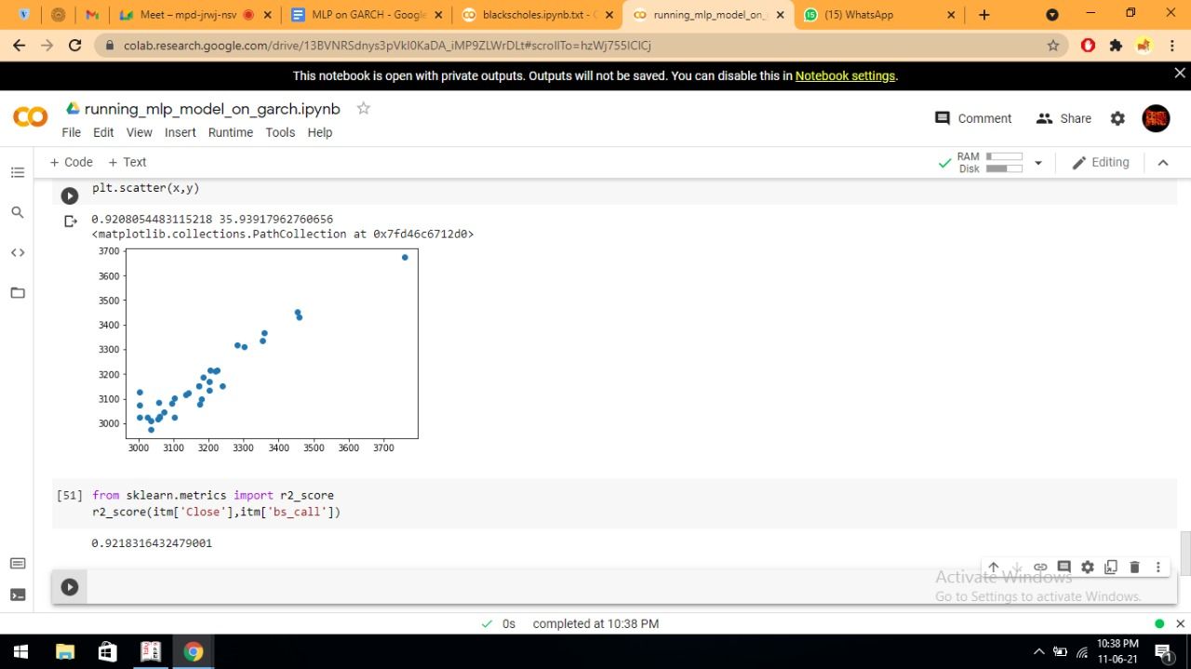

Black Scholes model on OTM dataset(Garch Dataset)

Accuracy- 15.1975 MAE- 74.4166

